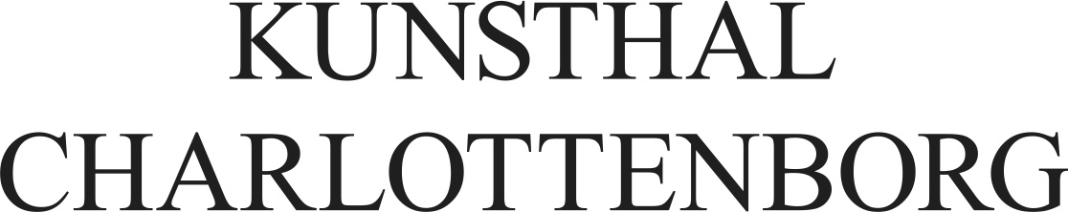

Press release May 2016
Brian Eno’s first solo exhibition in Denmark since 1992 is shown at Kunsthal Charlottenborg, Heartland Festival and CHART ART FAIR.
The legendary musician, producer and artist Brian Eno presents the exhibit The Ship in Denmark this summer as a result of collaboration between Kunsthal Charlottenborg, CHART ART FAIR and Heartland Festival.

All summer from June 12 to August 7, Brian Eno's sound art installation The Ship will be exhibited at Kunsthal Charlottenborg in collaboration with CHART ART FAIR, which will exhibit the art work as part of the CHART SOCIAL program during CHART ART FAIR from August 26-28. The work will be premiered at the Heartland Festival at Egeskov Castle June 10-11.

The Ship is the first solo exhibition of Brian Eno in Denmark since 1992. The work is a comprehensive sound art installation that evolves over time. The Ship is specially designed by Brian Eno to each room it is displayed in. Therefore, the experience of the sound installation at Heartland Festival, Kunsthal Charlottenborg and CHART ART FAIR will be unique.
Brian Eno, who started his career in legendary Roxy Music, is best known as a pioneer within ambient and electronic music, where he has both created music under his own name and produced for some of the biggest artists in the music business. Alongside his career within music, Brian Eno has however also gained recognition as an artist, who works especially with sound art. He was educated at Ipswich School of Art, and his works have been exhibited in leading art institutions around the world. Among other things he was invited to exhibit at last year’s La Biennale di Venezia with the work The Creation of Sound.
The exhibition of Brian Eno's The Ship is made possible through a collaboration between Kunsthal Charlottenborg, CHART ART FAIR and Heartland Festival.

Brian Enos The Ship appears in Denmark:
June to 10-11 2016, Heartland Festival
June 12 to August 7 at Kunsthal Charlottenborg
August 26 to August 28 during CHART ART FAIR (taking place at Kunsthal Charlottenborg)

Read more at the following links:
kunsthalcharlottenborg.dk
heartlandfestival.dk
chartartfair.com

Facts about the exhibition at Kunsthal Charlottenborg
Brian Eno: The Ship
Opening: Sunday June 12 at 3.30 PM
Exhibition period: June 14 – August 7
Opening hours: Tuesday-Sunday 11 AM - 5 PM, Wednesday 11 AM – 8 PM
Mezzaninen, Kunsthal Charlottenborg, Kongens Nytorv 2, 1050 København K
Admittance: 60 DKK (Free admittance to the opening)
Read more and acces press material.
For further information please contact
Anders Koch Madsen
Kommunikationsansvarlig, Kunsthal Charlottenborg
am@kunsthalcharlottenborg.dk / 3374 4629

