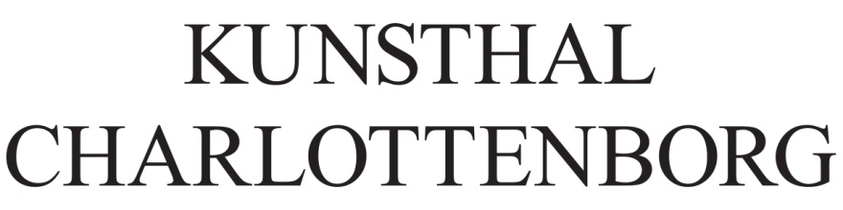

Press Release, Copenhagen, 27 May 2019

Jesper Just’s Servitudes transforms Kunsthal Charlottenborg’s spaces into a performative and immersive installation
This summer, Kunsthal Charlottenborg opens the doors to internationally renowned Danish artist Jesper Just with the one-work exhibition Servitudes. By presenting a spatial installation that disrupts the visitor’s experience, Just questions ideas of representation and agency that permeate contemporary society. The exhibition is initiated in collaboration with MAAT – Museum of Art, Architecture & Technology in Lisbon, and curated by Irene Campolmi.

Exhibition period: 15 June – 11 August 2019
Official opening: 14 June 6–10pm
Press view: 14 June 12–13pm

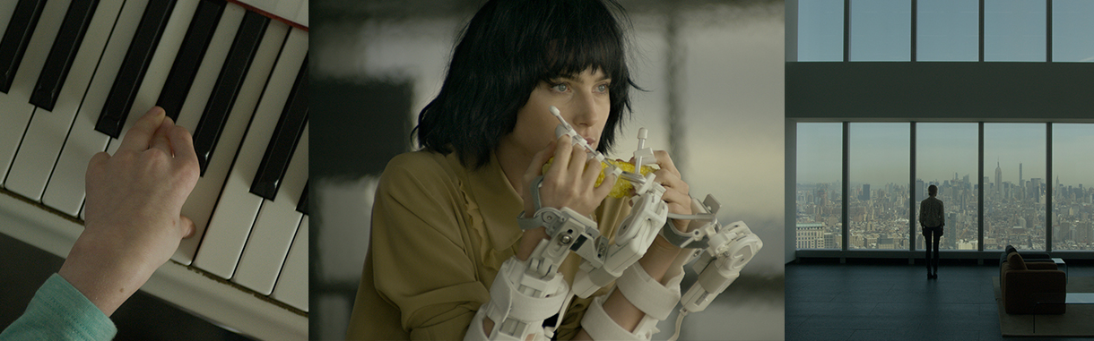

Servitudes is a video installation that shows eight synchronised 9-minute films on a loop. It investigates the ambiguity and sensuality of youth, the striving for beauty, and how humankind’s agency inverts the conventional understanding of ability and disability. The work traces a journey into opposed yet interdependent ideas of agency and representation that permeate contemporary society, and which are central to Just’s practice. Using the architecture as a medium, Just transforms Kunsthal Charlottenborg’s south wing into a complex spatial installation, where a monumental architecture of scaffolding structure offers a narrow path made for wheelchair access as the only way to go through it. The installation invites - and forces, at the same time - the visitor to perform a score by adjusting an ‘able’ body to unexpected conditions and, thus, testing ideas of agency of the body that often recur in Western society.

Deconstructing notions of agency and representations in Western post-consumerist society
As we proceed through the scaffolding structure of Servitudes, along the narrow path made for a wheelchair user, we come across eight projections. They revolve around the fictional fragments of the lives of two girls. On the one hand, Dree Hemingway, the great-granddaughter of the writer and quintessential figure of masculinity, Ernest Hemmingway, embodies a hyper-sexualized western ideal of youth and female beauty, who nonetheless seems incapable of acting upon her desires. On the other hand, Rylee Sweeney, a child afflicted by Charcot-Marie-Tooth disease, a neurological disorder that affects the motor and sensory nerves, is portrayed as someone who overcomes her disability. In fact, the artist assigns her the role of creating the music that guides the visitor throughout the whole installation, showing her effort and pride in playing on the piano Chopin’s Opus 17.

On the backdrop of each film stands the iconic One World Trade Center in New York, a prosthesis of the
city, which occupies the void left by the traumatic loss of the Twin Towers. The architecture, here perceived as a phantom limb, becomes the third protagonist of this piece. The characters (the girl, the child and the building) appear to be hybrids of machines and organisms, whose existence blurs the boundaries between fiction and experience.

First premiered at Palais de Tokyo in 2015, Servitudes has also been shown the same on the
billboards of the iconic Times Square in New York and is now part of the collection of the Metropolitan
Museum of Art in New York.

Jesper Just
Jesper Just (b. 1974) is a Danish artist, who lives and works in New York. Over the past ten years, he has received international recognition for the rigorous precision and the insightful and emotional charge of his short films, exploring and deconstructing conventional representations of gender, love, social roles and body. He represented Denmark in the 55th Venice Biennale (2013) and has been exhibited internationally, more recently at Palais de Tokyo (2015), Performa (2015), the Royal Theatre of Copenhagen (2017) with the live performance Interpassivities, Museo Anahuacalli in Mexico City (2017) and MAAT – Museum of Art Architecture and Technology in Lisbon (2019). He attended the Royal Danish Academy of Fine Arts, Schools of Visual Arts, in 1997–2003.

The exhibition is curated by Irene Campolmi, independent curator and researcher based in Copenhagen.

Servitudes is supported by the Augustinus Foundation, Aage & Johanne Louis-Hansen’s Foundation, Beckett Foundation, Danish Arts Foundation, Knud Højgaard’s Foundation, Konsul George Jorck & Hustru Emma Jorck’s Foundation, New Carlsberg Foundation, Obel Family Foundation and sponsored by Dansk Stillads Service, Kvadrat, Flügger group A/S, Statens Værksteder for Kunst.

A special thanks to Kristine Bech Sørensen, Katre Laura, FOS, Dree Hemingway.

Facts
Jesper Just: Servitudes
15 June – 11 August 2019
Official opening: 14 June 6pm-10pm
Kunsthal Charlottenborg, Kongens Nytorv 1, 1050 Copenhagen K
DKK 90. (Admission to the official opening is free)
More about the exhibition

Photo credit
Jesper Just, Servitudes, 2015. Video still, eight-channel digital video, color, sound, 9 min. Courtesy the artist, Galleri Nicolai Wallner and Galerie Perrotin.

Press materials
Press materials, including high-resolution images, can be downloaded from Kunsthal Charlottenborg’s website: kunsthalcharlottenborg.dk/en/exhibitions/jesper-just/

For additional information and materials, please contact
Irene Campolmi, curator
campolmi.irene@gmail.com or +45 2869 7337

or

Jeannie Møller Haltrup
Head of Communications, Kunsthal Charlottenborg
jmh@kunsthalcharlottenborg.dk / (+45) 3374 4629
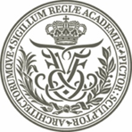
www.kunsthalcharlottenborg.dk
www.facebook.com/charlottenborg.kunsthal
www.instagram.com/kunsthalcharlottenborg
www.twitter.com/charlottenborg
www.vimeo.com/user13552023

